Dear All,

Thank you for the attached documents.
But are they all approved, do they have comments? Or what should we do with them?

There is no stamp on the coverpage saying whether they are approved or not. See below examples of previous documents.

Please stamp the attached documents approved or commented and send them back to us.

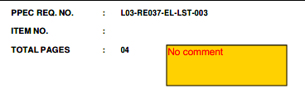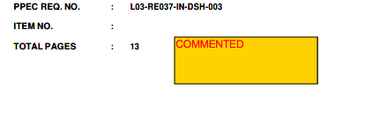

Best regards,

Client reply:
Please refer to attached file.

