STYRENE PARK OFFSITE

N2 Filling Procedure
for Ru0001A / B-D-02

R0 | 08-04-2025 | IFA | F.Malekifar | M.Yasini | GH.Azizi
Rev. | Issued Date | DESCRIPTION | PREPARED | CHECKED | APPROVED

REVISION RECORD SHEET
Page  Page | Revisions |  |  |  |  |  |  |  | Page | Revisions
Page  Page | R0 | R1 | R2 | R3 | R4 | R5 | R6 |  | Page | R0 | R1 | R2 | R3 | R4 | R5 | R6
1 | X |  |  |  |  |  |  |  | 41
2 | X |  |  |  |  |  |  |  | 42
3 | X |  |  |  |  |  |  |  | 43
4 | X |  |  |  |  |  |  |  | 44
5 | X |  |  |  |  |  |  |  | 45
6 | X |  |  |  |  |  |  |  | 46
7 |  |  |  |  |  |  |  |  | 47
8 |  |  |  |  |  |  |  |  | 48
9 |  |  |  |  |  |  |  |  | 49
10 |  |  |  |  |  |  |  |  | 50
11 |  |  |  |  |  |  |  |  | 51
12 |  |  |  |  |  |  |  |  | 52
13 |  |  |  |  |  |  |  |  | 53
14 |  |  |  |  |  |  |  |  | 54
15 |  |  |  |  |  |  |  |  | 55
16 |  |  |  |  |  |  |  |  | 56
17 |  |  |  |  |  |  |  |  | 57
18 |  |  |  |  |  |  |  |  | 58
19 |  |  |  |  |  |  |  |  | 59
20 |  |  |  |  |  |  |  |  | 60
21 |  |  |  |  |  |  |  |  | 61
22 |  |  |  |  |  |  |  |  | 62
23 |  |  |  |  |  |  |  |  | 63
24 |  |  |  |  |  |  |  |  | 64
25 |  |  |  |  |  |  |  |  | 65
26 |  |  |  |  |  |  |  |  | 66
27 |  |  |  |  |  |  |  |  | 67
28 |  |  |  |  |  |  |  |  | 68
29 |  |  |  |  |  |  |  |  | 69
30 |  |  |  |  |  |  |  |  | 70
31 |  |  |  |  |  |  |  |  | 71
32 |  |  |  |  |  |  |  |  | 72
33 |  |  |  |  |  |  |  |  | 73
34 |  |  |  |  |  |  |  |  | 74
35 |  |  |  |  |  |  |  |  | 75
36 |  |  |  |  |  |  |  |  | 76
37 |  |  |  |  |  |  |  |  | 77
38 |  |  |  |  |  |  |  |  | 78
39 |  |  |  |  |  |  |  |  | 79
40 |  |  |  |  |  |  |  |  | 80
PURPOSE and SCOPE:

The Receiver performs various important functions. They are: To separate the liquid out of the gas and allow the gas to pass to the flare line, to drain the liquid from the flare line. The third function of a Receiver is to absorb the violent liquid surging that occurs when the flare line is quickly opened.
According to mentioned sentences, the N2 purge procedure is very important.
Nitrogen is dry and non-combustible, and the nitrogen displacement of combustible gases will prevent an unstable and potentially ignitable atmosphere. Simply put, the use of nitrogen in oil and gas industry equipment effectively displaces moisture and oxygen and creates a more stable climate.
Nitrogen Purging can vary greatly depending on the scope of work and equipment being
utilized. The following procedure therefore contains phrases such as: if required and if
applicable in many of the steps. This procedure is intended to allow the user to follow the steps appropriate to the work being done. Each step should be considered and if applicable be followed as part of the procedure. The written Job Specific Execution Plan should outline any steps required for the purge that are not covered in this general procedure.
Nitrogen Purging activities must be performed by competent and qualified persons.
Pipeline purging with nitrogen gas is a critical component of natural gas line commissioning for flow lines. This procedure is necessary to eliminate oxygen, water vapor, and other impurities that are retained within a newly laid pipeline network. Failure to eliminate these substances will alter the quality of fluids being transported through the flow lines.
N2 purging is a pretty straightforward procedure where the pressurized gas is forced through the lumen of the selected pipelines forcing out all gaseous and particulate impurities.

REFERENCES
PIPELINE PURGING PRINCIPLES AND PRACTICE, IPC1996-1882

The Step-By-Step Process for N2 purge procedure:
After sandblasting and painting is finished, following procedure is adopted:
1- Interior surface is cleaned and every impurity is removed.
2- Interior surface is fully dried.
3- All nozzles are sealed with steel cap, proper gasket, bolts and nuts.
4- Azot gas is injected into the surge drum with an approximate pressure of 0.5 BAR.
5- Direct purging is used Purging pipelines are cleaned by this type of purging widely and successfully. Direct purging is quite acceptable as pipelines are linear structures and providing the velocity of the gases involved are kept within acceptable limits, the quantity of mixed gas and air, perhaps representing a flammable hazard, is kept to a minimum and direct.

Safety
Conducting N2 purging in an industrial setting comes with inherent risks. To ensure the safe execution of pipeline purging, operators should adhere to the following concise steps:
Ensure meticulous instruments/apparatus handling
Properly train and brief all personnel on how to safely perform their duties
Designate emergency protocols for shut down and personnel evacuation with the provision of multiple points of egress
Mandatory use of personal protective equipment by all personnel involved in purging operations

Reporting
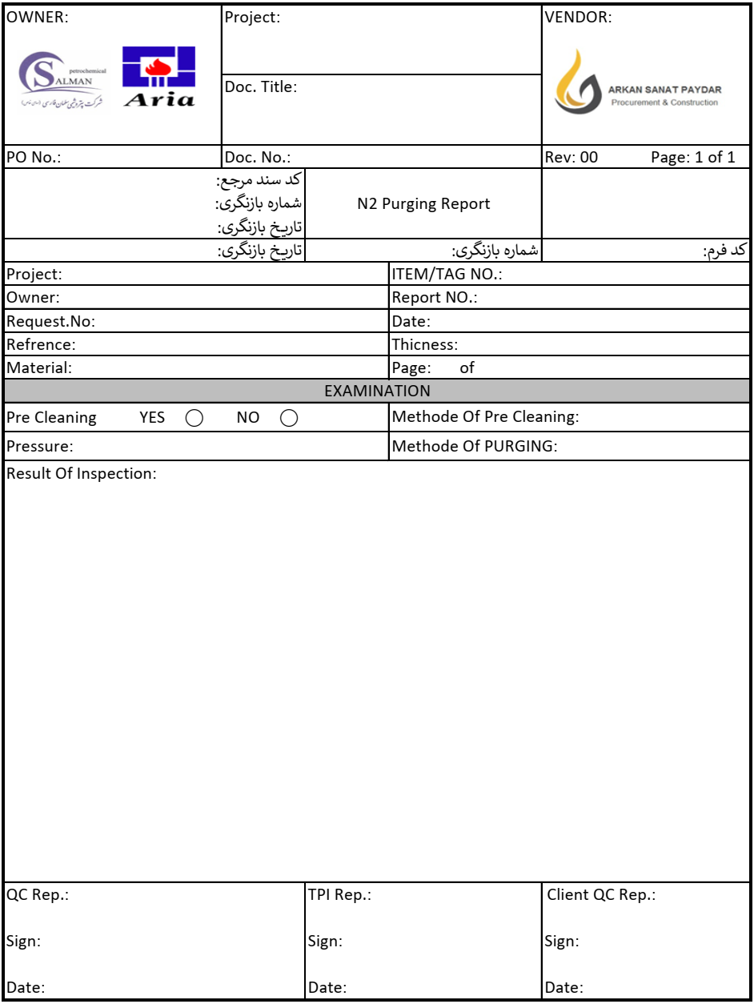
After purging, all necessary information shall be reported in Report form:

