PURCHASE ORDER Ref.: ENER-MME-2024-001

Date: 29Feb2024

ATT To: MAYEKAWA MIDDLE EAST FZCO

Re: You’re Quotation No. SQ24000081 R1 dated 28.Feb.2024
Further to your above-mentioned quotation, now we have the pleasure to place the above mentioned order for the following items:

Item | Model No. | Description | Qty. | Unit Price  EUR | Total Price  EUR
 |  | BARE SCREW COMPRESSOR
1. | 160V-S | MYCOM standard skid mounted Screw Compressor Unit P160V-S with  Compressor, Oil Pump, Compressor Coupling, Thermisiphon Oil Cooler, Oil separator, Lube oil Filter  with Exi indicator assy. | 2 |   70,000.00 | 140,000.00
 |  | Total Value of Goods: |  | EUR | 140,000.00
 |  | Total EX-W Belgium: |  | EUR | 140,000.00

Purchase Order Terms & Conditions:

Price: The total price for this order is EUR 140,000.0. Terms of Delivery: Ex-works Belgium
Terms of Payment: CASH in AED as per Xe.com rate

Delivery Time: TBA

Address: 19 Mayis Mah.Turaboğlu Sk. Hamdiye Yazgin is Merkezi 4/2 Kadiköy - Istanbul Tel: +90 216706189 Fax: +902163868011 Email: info@ener-teknoloji.com

Other Terms and Conditions:

- Certificate of Origin of Belgium to be issued.
- Manufacture test certificate is required

- In case of using JIS material Mating flange to be supplied by MME.

- Compressors and Oil pumps will be shipped by MME to ME at Buyer Costs.

- Motors/Heaters will be delivered by Buyer to MAYEKAWA Europe Facilities for final assembly.

- Size/ specification of Heater Nozzle and Heater KW to be specified by SELLER, and quotation of Heater to be verified by SELLER.
- Instrument holes should be in a way that Exi instruments can be installed on the compressor skid.

- Motor Baseplate should be designed and manufactured in a way that Project motors can be mounted on the skid.

- Oil cooler(water cooled) should be designed/manufactured in a way that it can handle 37 C inlet with 5 degree difference as per project PFD.
- Following Documents to be provided after order:

  - General Arrangement Drawing for Compressor Unit
  - PID for Compressor Unit
  - Maintenance Manual and Operation Manual
  - Storage and Preservation Procedure
  - Final Book (Including Inspection Data Book and drawings of items inside the package)

- Final Book comprising General drawing, bill of material, installation and maintenance and operation manual, Test Reports, Part list, Data sheet, other listed documents, storage and preservation procedure should be provided by Manufacturer at time of delivery

Address: 19 Mayis Mah.Turaboğlu Sk. Hamdiye Yazgin is Merkezi 4/2 Kadiköy - Istanbul Tel: +90 216706189 Fax: +902163868011 Email: info@ener-teknoloji.com

Shipping Documents:

The following Original Documents should be sent along with goods.

- Signed, Stamped Detailed Commercial Invoice
- Signed & Stamped Detailed Packing List
- COO

Delivery Delay:

Delivery shall be made without any delay. In case of any delay to deliver the Products, the Buyer shall be entitled to charge the Seller with liquidated damages up to 5% of the total price, based on 0.5% per day computed from the day after the due date to actual delivery date.

Packaging:

Suitable packing which should be capable of withstanding sea shipment

Markings:

The following marking is required on two sides of each package:
Order No.: ENER-MME-2023-001
Gross weight:
Net weight:
Date of Manufacturing: Batch/Lot No.:
Package number … of …

Address: 19 Mayis Mah.Turaboğlu Sk. Hamdiye Yazgin is Merkezi 4/2 Kadiköy - Istanbul Tel: +90 216706189 Fax: +902163868011 Email: info@ener-teknoloji.com

Inspection:

None

Monitoring by representative at ME/MME Facility:
(Review of documents, dimensions, test as per approved procedure)

Review of documents:
(Certificate of materials, test report, quantity, marking, packing, certificate of analysis, MSDS)

Warranty: All equipment, material and component parts shall be guaranteed by vendors against defective material, design and workmanship when operated under normal conditions for a period of 12 months after being placed in service, but not exceeding 24 months after date of shipment, the vendors undertake to replace defective and/or missing items at their expense.

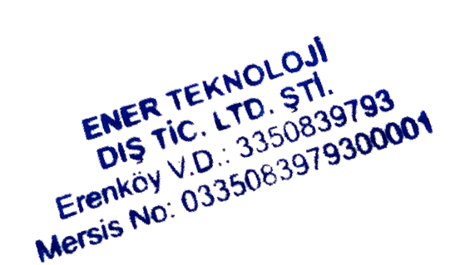
Yours Faithfully
ENER TEKNOLOJI Co.

Address: 19 Mayis Mah.Turaboğlu Sk. Hamdiye Yazgin is Merkezi 4/2 Kadiköy - Istanbul Tel: +90 216706189 Fax: +902163868011 Email: info@ener-teknoloji.com

