   |  | Toase-ehe Park Sanati Gohar Ofogh  Petrochemical Co.  CONCEPTUAL, BASIC and DETAIL DESIGN ENGINEERING OF STYRENE PARK OFFSITE |     
 |  | Document Title: HSE PLAN
 |  | Document No.: EI027-FPA-VD-GE-HSE-005 | Rev. R0 | Page 1 of 43

STYRENE PARK OFFSITE

Document Title:
Health, safety and environment plan
HSE PLAN

R0 | 11-09-2024 | IFA | E. Jahangiri | S. Baitar | H. Zahiri
Rev. | Issued Date | DESCRIPTION | PREPARED | CHECKED | APPROVED

Toase-ehe Park Sanati Gohar Ofogh
Petrochemical Co.
CONCEPTUAL, BASIC and DETAIL DESIGN ENGINEERING OF STYRENE PARK OFFSITE
 |  | Document Title: HSE PLAN
 |  | Document No.: EI027-FPA-VD-GE-HSE-005 | Rev. R0 | Page 2 of 43

REVISION RECORD SHEET
Page  Page | Revisions |  |  |  |  |  |  |  | Page | Revisions
Page  Page | R0 | R1 | R2 | R3 | R4 | R5 | R6 |  | Page | R0 | R1 | R2 | R3 | R4 | R5 | R6
1 | X |  |  |  |  |  |  |  | 41 | X
2 | X |  |  |  |  |  |  |  | 42 | X
3 | X |  |  |  |  |  |  |  | 43 | X
4 | X |  |  |  |  |  |  |  | 44
5 | X |  |  |  |  |  |  |  | 45
6 | X |  |  |  |  |  |  |  | 46
7 | X |  |  |  |  |  |  |  | 47
8 | X |  |  |  |  |  |  |  | 48
9 | X |  |  |  |  |  |  |  | 49
10 | X |  |  |  |  |  |  |  | 50
11 | X |  |  |  |  |  |  |  | 51
12 | X |  |  |  |  |  |  |  | 52
13 | X |  |  |  |  |  |  |  | 53
14 | X |  |  |  |  |  |  |  | 54
15 | X |  |  |  |  |  |  |  | 55
16 | X |  |  |  |  |  |  |  | 56
17 | X |  |  |  |  |  |  |  | 57
18 | X |  |  |  |  |  |  |  | 58
19 | X |  |  |  |  |  |  |  | 59
20 | X |  |  |  |  |  |  |  | 60
21 | X |  |  |  |  |  |  |  | 61
22 | X |  |  |  |  |  |  |  | 62
23 | X |  |  |  |  |  |  |  | 63
24 | X |  |  |  |  |  |  |  | 64
25 | X |  |  |  |  |  |  |  | 65
26 | X |  |  |  |  |  |  |  | 66
27 | X |  |  |  |  |  |  |  | 67
28 | X |  |  |  |  |  |  |  | 68
29 | X |  |  |  |  |  |  |  | 69
30 | X |  |  |  |  |  |  |  | 70
31 | X |  |  |  |  |  |  |  | 71
32 | X |  |  |  |  |  |  |  | 72
33 | X |  |  |  |  |  |  |  | 73
34 | X |  |  |  |  |  |  |  | 74
35 | X |  |  |  |  |  |  |  | 75
36 | X |  |  |  |  |  |  |  | 76
37 | X |  |  |  |  |  |  |  | 77
38 | X |  |  |  |  |  |  |  | 78
39 | X |  |  |  |  |  |  |  | 79
40 | X |  |  |  |  |  |  |  | 80

Toase-ehe Park Sanati Gohar Ofogh
Petrochemical Co.
CONCEPTUAL, BASIC and DETAIL DESIGN ENGINEERING OF STYRENE PARK OFFSITE
 |  | Document Title: HSE PLAN
 |  | Document No.: EI027-FPA-VD-GE-HSE-005 | Rev. R0 | Page 3 of 43

Project Title:
STYRENE PARK OFFSITE

contract number:
DELTA-FARNIKAN-2024-PO-200

Contractor:
Ali Tayari

Workshop location:
Farnikan Pars Avin Company

Certificate number and revision:
EI027-FPA-VD-GE-HSE-005

Toase-ehe Park Sanati Gohar Ofogh
Petrochemical Co.
CONCEPTUAL, BASIC and DETAIL DESIGN ENGINEERING OF STYRENE PARK OFFSITE
 |  | Document Title: HSE PLAN
 |  | Document No.: EI027-FPA-VD-GE-HSE-005 | Rev. R0 | Page 4 of 43

the introduction:
The health, safety, and environment plan are a living and dynamic proof of how to achieve the HSE goals of the mentioned project, which is prepared by the HSE unit of Farnikan Pars Avin Company and will be updated if necessary. In the preparation of this HSE PLAN, all legal requirements, health requirements, safety requirements, environmental requirements, resource consumption requirements, workshop equipment requirements, environmental restoration requirements, the list of major risks, manpower structure requirements, relevant implementation methods, etc. have been taken into account.
- Purpose:
The purpose of this HSE PLAN is to describe and explain all the activities affecting safety, health, and environment to prevent the occurrence of life accidents, financial losses, and occupational diseases of all the beneficiaries, to prevent the creation of environmental damages, and to improve HSE performance. This plan is the basis for the safety, health, and environment management system in the mentioned project, which is explained to all active colleagues, newly employed forces, and subcontractors related to this company and the mentioned project, and they are also obliged to comply with all the matters.
- Scope of application:
This plan is valid in all the working environments of Farnikan Pars Avin Company and the construction project of shell and tube heat exchangers of STYRENE PARK OFFSITE for all colleagues, and contractors (main and subcontractors).
It should be noted that working environments mean any physical place where activities related to project operations are carried out, from the beginning to the time of packing and loading.
- Definitions:
- Employees: It refers to all people who are employed in the company on an official or contractual basis.
- Risk: source, situation, or action that has the potential of harm, in the form of injury, illness, financial losses, or a combination of them.
- Risk identification: the identification process of recognizing the existence of a risk and defining its characteristics
- Health and safety risk: a combination of the possibility of a dangerous event and the severity of the injury, illness, or damage caused by that event.
Toase-ehe Park Sanati Gohar Ofogh
Petrochemical Co.
CONCEPTUAL, BASIC and DETAIL DESIGN ENGINEERING OF STYRENE PARK OFFSITE
 |  | Document Title: HSE PLAN
 |  | Document No.: EI027-FPA-VD-GE-HSE-005 | Rev. R0 | Page 5 of 43

- Safety: degree of distance from danger
- Event: A work-related event whereby an injury, illness (regardless of its severity), death, or property damage has occurred or may occur.
- Accident: An accident is an event that leads to injury, illness, death, or damage to property
- Quasi-accident: An event in which injury, illness or death, or property damage does not occur, is referred to as a "quasi-accident", "quasi-accident", "accident" or a dangerous event.
- Occupational disease: Diagnosable and unfavorable physical or mental (spiritual) conditions that result from a work activity or work environment or worsen as a result of that activity/work environment.
- Environmental: an environment including air, water, soil, natural resources, plants, animals, humans, and mutual relations between them in which the organization operates. This environment includes the organization of the whole world.
- Environmental aspect: A part of an organization's activities, products, or services that can interact with the environment.
- Environmental consequence: Any change in the environment, either favorable or unfavorable, which is all or part of it caused by the environmental aspects of an organization.
- Environmental risk: a combination of the probability of an environmental aspect occurring and the severity of its consequences, whether this consequence occurs gradually or is catastrophic.
- Stakeholder: A person or group that is related to or affected by the organization's HSE performance.
- Non-conformity: Failure to meet a requirement, a non-conformity can be any deviation from the following:
  - Working standards, specialized instructions, implementation methods, legal requirements
  - Requirements stated in the HSE plan
- Preventive action: action taken to eliminate the cause of a potential non-conformity.
- Corrective action: Action taken to eliminate a discovered non-conformity.
- Accountability: The ultimate responsibility of individuals within the scope of their authority, which is defined by their "job description". This issue also includes the authority delegated to lower ranks either temporarily or permanently.
Toase-ehe Park Sanati Gohar Ofogh
Petrochemical Co.
CONCEPTUAL, BASIC and DETAIL DESIGN ENGINEERING OF STYRENE PARK OFFSITE
 |  | Document Title: HSE PLAN
 |  | Document No.: EI027-FPA-VD-GE-HSE-005 | Rev. R0 | Page 6 of 43

- Air pollution: gases, vapors, and suspended particles that are released in the air.
- Competence: the ability to perform a specific task according to work standards
- Contingency Plan: A pre-established plan to mitigate the effects of an unusual situation that has the potential to cause harm.
- Emergency: an emergency is a result of a major accident the extent of the emergency depends on the type and extent of the incident. After that, the number of organizations that are involved in this situation and the extent of dealing with the emergency depends on the severity of the incident.
- Potentially damaging factors: Unsafe conditions or practices are said to have the potential to cause an accident. In other words, it is considered an accident factor that occurs when combined with one or more other accident factors.

Toase-ehe Park Sanati Gohar Ofogh
Petrochemical Co.
CONCEPTUAL, BASIC and DETAIL DESIGN ENGINEERING OF STYRENE PARK OFFSITE
 |  | Document Title: HSE PLAN
 |  | Document No.: EI027-FPA-VD-GE-HSE-005 | Rev. R0 | Page 7 of 43

- Policy:

Farnikan Pars Avin Company
HSE management system policy
Farnikan Pars Avin Company is active in the field of designing and manufacturing equipment and process units for various industries such as oil, gas, petrochemical, water, and power plant industries. With the help of Almighty God and the support of expert and skilled manpower, by creating process-oriented thinking, it has taken a big step towards improving the quality of its services, customer satisfaction, improving environmental performance, safety, professional hygiene, and employee health, for this purpose He has implemented the HSE management system at the company level and considers himself bound and committed to the following principles:
❖ Compliance with national and international standards.
❖ Development of safety, health, and environmental culture and development of organizational values.
❖ Targeted and practical training of employees for continuous improvement of all company processes and activities and promotion of teamwork.
❖ Enhancing the morale and motivation of employees by attracting their participation and improving the quality of work.
❖ Reducing and preventing environmental pollution and producing environmentally friendly products
❖ Continuous reduction of accidents, maintenance and improvement of safety and health of employees, and continuous improvement of the system
❖ Implementing and maintaining legal requirements related to environmental, safety, and health aspects at the organizational level

Toase-ehe Park Sanati Gohar Ofogh
Petrochemical Co.
CONCEPTUAL, BASIC and DETAIL DESIGN ENGINEERING OF STYRENE PARK OFFSITE
 |  | Document Title: HSE PLAN
 |  | Document No.: EI027-FPA-VD-GE-HSE-005 | Rev. R0 | Page 8 of 43

To achieve the above principles, this company has implemented the HSE management system at all levels and is constantly committed to the continuous and effective improvement of this system. Also, at the beginning of each year, the company sets safety and health goals and the environment acts in line with this policy and reviews through monitoring, measuring, and analyzing the degree of realization of the defined safety, health, and environmental goals.
I support this system with full belief and firm determination. I expect each of the company's colleagues to understand it correctly, try to meet and maintain the standard demands of the HSE management system, and continuously improve it in their organizational position.
CEO

Toase-ehe Park Sanati Gohar Ofogh
Petrochemical Co.
CONCEPTUAL, BASIC and DETAIL DESIGN ENGINEERING OF STYRENE PARK OFFSITE
 |  | Document Title: HSE PLAN
 |  | Document No.: EI027-FPA-VD-GE-HSE-005 | Rev. R0 | Page 9 of 43

- Targeting:
Farnikan Pars Avin Company is trying to achieve the HSE policy through the following goals:
  - Conducting HSE-related training
  - Implementation of operations and all project activities without death or disability and with the least amount of minor damage
  - Reducing the average risk number of risks and aspect evaluation number
  - Reducing the rate of accident indicators (FSI)
  - Completion and provision of HSE-related equipment in the project according to the needs assessment
  - Reduction of environmental pollutants caused by maintenance activities, storage tanks for petroleum materials and machines, improving the health status in the company, canteen, and public space of the factory.
  - Reduction in the rate of quasi-accidents (preventive goal)
  - Reduction in the rate of accidents (company/contractor forces) (remedial goal)
  - Reduction in the number of work-related diseases (remedial goals)
  - Reduction in per capita energy consumption
  - Increasing the rate of separation of waste
  - Reducing the production of greenhouse gases and pollutants
  - Per capita increase in HSE training (preventive)

- Responsibilities:
project manager:
He will be responsible for the overall HSE issues of the project. Other responsibilities include the following:
- Ensuring the establishment, implementation, preservation, and maintenance of the HSE system and updating it according to the needs and risks in the various stages of the project
- Supervising the HSE issues of the project and providing the required resources and equipment
- Supervising the selection and evaluation of hired employees, subcontractors, equipment, and tools affecting HSE in the project
- Ensuring that all employees and contractors are aware of and comply with legal requirements (whether local or national) and other legal requirements applicable to the project.
Toase-ehe Park Sanati Gohar Ofogh
Petrochemical Co.
CONCEPTUAL, BASIC and DETAIL DESIGN ENGINEERING OF STYRENE PARK OFFSITE
 |  | Document Title: HSE PLAN
 |  | Document No.: EI027-FPA-VD-GE-HSE-005 | Rev. R0 | Page 10 of 43

Site Manager:
He is accountable to the project manager regarding the implementation and provision of requirements according to the HSE PLAN of the project. Other responsibilities include the following:
- Implementation of project manager's decisions (regarding safety, health, and environment in the workshop)
- Studying the general and private conditions of the contract (about the HSE conditions that can be implemented in the project)
- Appropriate use of HSE allocated financial resources
- Studying implementation methods and safety, health, and environmental guidelines and controlling their correct implementation
- Supervising the preservation of all properties and assets of the workshop under supervision.
- Warning and legal action against wrongdoers, in the fields of safety, health, and environment
Workshop HSE Officer:
  - Monitoring the implementation of health, safety, and environment guidelines in all workshop activities.
  - Providing monthly reports of relevant forms
  - Notification of need and follow-up, safety and health equipment, and workshop environment
  - Notification of need and follow-up, to hire a doctor, health and safety expert
  - Introducing wrongdoers, in the field of safety, health, and environment, and following up on how to deal with such people
  - Random visits to active areas and departments
  - Responsibility for following up on all approvals of the safety committee meeting until reaching the final result
  - Safety and health and environment training at the workshop level
  - Daily and periodical visits to active regions and departments

Toase-ehe Park Sanati Gohar Ofogh
Petrochemical Co.
CONCEPTUAL, BASIC and DETAIL DESIGN ENGINEERING OF STYRENE PARK OFFSITE
 |  | Document Title: HSE PLAN
 |  | Document No.: EI027-FPA-VD-GE-HSE-005 | Rev. R0 | Page 11 of 43

Other personnel:
All personnel in the project have a written job description, which will be communicated to them by the relevant unit before starting the activity. Apart from the specified tasks, all personnel in the project have a description of general safety, health, and environmental duties, which include the following:
  - Introducing yourself to the HSE unit before starting work on the project to communicate the requirements
  - Use of appropriate personal protective equipment according to the type of activity
  - Getting to know the requirements related to HSE PLAN, safety, health and environment, and working and legal requirements and fully complying with them
  - Incident reporting (accidents, events, and damage to property and assets and equipment) and cooperation in recording, reviewing, and managing it with the relevant authorities.
  - Cooperation in the risk assessment process with HSE officials
  - Not performing any unsafe act that endangers the health of other people.
  - Not using drugs
  - Submitting a proposal to the head of the HSE unit to improve the safety, health, and environmental situation

- Project organizational chart (HSE) and description of HSE unit duties

Toase-ehe Park Sanati Gohar Ofogh
Petrochemical Co.
CONCEPTUAL, BASIC and DETAIL DESIGN ENGINEERING OF STYRENE PARK OFFSITE
 |  | Document Title: HSE PLAN
 |  | Document No.: EI027-FPA-VD-GE-HSE-005 | Rev. R0 | Page 12 of 43

Job Title: Health, Safety and Environment (HSE) Manager
Eligibility conditions
1- Education: Bachelor of Occupational Health and Safety / Bachelor of Industrial Safety / Bachelor of HSE
2- Experience: at least 4 years
3- Necessary skills: communication skills / team work / time management skills and analytical and reporting skills / familiarity with first aid / familiarity with HSE requirements / risk assessment in order to identify hazards caused by activities / familiarity with safety and health rules related to the activity / Familiarity with environmental laws related to the activity / Familiarity with fire extinguishing methods / Passing the ICDL course / Familiarity with English language and...
Duties
- Formation of technical safety and work hygiene committee and description of corrective measures regarding HSE in the meetings
- Forming health records for personnel and following up on periodic occupational examinations
- Referral of new personnel to occupational medicine to perform pre-employment examinations
- Training the company's health and safety principles to new employees, and documented training on HSE topics for all personnel
- Cleaning and hygiene control in all departments of the company, including restrooms, resorts, kitchens, etc.
- Monitoring the safety performance of devices and compliance with safety instructions by personnel
- Coordination in the audit of environmental, safety and health management aspects, risks and systems
- Identifying and evaluating health and safety risks, environmental aspects and taking corrective measures for obvious risks
- Pursuing matters related to the measurement of harmful factors in the work environment, with approved companies, receiving reports from them and taking corrective measures.
- Conducting maneuvers in order to prepare for emergency situations according to the relevant instructions and procedures
- Pursuing the provision of equipment for announcing, extinguishing fire and charging capsules
- Understanding the policy and goals of the company and trying to comply with its principles.
- Planning and implementing the necessary measures to comply with safety, occupational health and environmental requirements.
- Updating the requirements of safety, occupational health and environment and informing all employees of the legal requirements of safety and environment.
- Issuing Work Permit for risky activities.
- Identifying and determining safe places in cooperation with building management/maintenance and repairs.
- Cooperate in compiling emergency exit location maps and safe places.
- Registering incidents and quasi-accidents and reporting incidents/quasi-accidents and analyzing them.
- Disciplinary actions with employees and contractors in case of non-compliance with safety, health and environmental issues
- Planning to obtain safety approvals for machinery from inspection companies or competent centers.
- Identifying the chemicals used in the organization and preparing the MSDS chemical information sheet
- Checking the inventory status of the first aid box and coordination to update the first aid box equipment.
- Compilation of information on the purchase of occupational health and safety equipment including PPE, safety signs and...
- Request for the purchase of occupational health and safety and environmental equipment.
- Planning for the separation of waste from the source in administrative and operational units.
- Communicating with competent organizations such as health and treatment center, labor department regarding safety, occupational health and environment issues.
- Following up on the approvals of the review of the management of the HSE management system.
- Keeping records of safety, occupational health and environment.
- Determining training needs and announcing to superiors.

Toase-ehe Park Sanati Gohar Ofogh
Petrochemical Co.
CONCEPTUAL, BASIC and DETAIL DESIGN ENGINEERING OF STYRENE PARK OFFSITE
 |  | Document Title: HSE PLAN
 |  | Document No.: EI027-FPA-VD-GE-HSE-005 | Rev. R0 | Page13 of 43

8- Risk management and HSE aspect
1-8- Identification and assessment of risks and environmental aspects
Risk management in the project is considered as the heart of the HSE management system, which Farnikan Pars Avin company has defined its HSE risk management method in all the different stages of the project implementation. The process of hazard identification and risk assessment is a continuous process and is reviewed and updated before and during the implementation of the project. The HSE unit of Farnikan Pars Avin Company identifies and evaluates the risks and harmful factors of the work environment according to the management method of identifying, evaluating, and controlling the risks and risks of environmental aspects with the code FPA-EPHSE01.
9- Legal requirements and standards
Farnikan Pars Avin Company will ensure compliance with national and regional requirements and laws in the project, as well as by creating and following the HSE-PLAN and requiring people to comply with it, work permit systems, inspections, job safety analysis, regular HSE audits and meetings in the project, operational procedures and health and safety guidelines and internal and external communication system related to HSE will ensure compliance with such requirements. This company is committed to all the requirements contained in the contract with the employer and considers all the above requirements to be valid for itself.
Laws and regulations related to the field of project activity have been identified and their relationship with risk, aspects, and related control instructions have been mentioned.
Also, all stakeholders in the company follow certain rules in general, which are referred to as:
1) All people who intend to enter the company must pass general safety courses organized by the HSE unit.
2) Smoking is prohibited in the production hall and the permitted place for smoking outside the production hall is specified.
3) All loading and unloading machines, before unloading and during loading, the method of unloading and loading must be approved by the HSE unit

Toase-ehe Park Sanati Gohar Ofogh
Petrochemical Co.
CONCEPTUAL, BASIC and DETAIL DESIGN ENGINEERING OF STYRENE PARK OFFSITE
 |  | Document Title: HSE PLAN
 |  | Document No.: EI027-FPA-VD-GE-HSE-005 | Rev. R0 | Page 14 of 43

The list of HSE rules and regulations related to project activities is described in the following table:
Row | The title of the activity | The title of the relevant instruction | Legal Authority
1 | Personal protective equipment | Instructions for using personal protective equipment | Personal Protective Equipment Regulations, Chapter 7, Article 49, Edition 89
2 | Storage of dangerous liquids | Instructions for working with chemicals and flammable materials | Regulations for the Protection of Hazardous Substances, Flammable Substances, and Explosive Substances, Chapter 4, Article 53, Edition 89
3 | Working with overhead and gantry cranes | Safety instructions for working with cranes | Regulations for transporting and moving materials and objects in the workshop / Chapter 3
4 | Work with a forklift | Forklift safety instructions | Forklift safety regulations
5 | Acid washing and industrial paint | Safety instructions for metal acid washing and painting | A comprehensive guide to working instructions for hazardous chemicals
6 | Sandblasting | sandblasting instructions | Article 250 of the safety regulation in casting industries (cutting and piping).
7 | Welding and cutting | Welding and cutting safety instructions | Welding and hot-cutting safety regulation
8 | Work with loading accessories | Safety instructions for loading and working with loading accessories | Transporting and moving materials and objects in the workshop Chapter 6
9 | Earthing | Earthing safety instructions | Grounding System Regulations
10 | Fire prevention and fighting | Fire safety instructions and how to extinguish the fire | Regulations for preventing and fighting against workshop fires
11 | Safety training | Executive instructions for safety training for employers, workers, and apprentices | Safety training regulations for employers, workers, and trainees, 1389 edition
12 | Work at height | Safety instructions for working at height and scaffolding safety | Safety regulations for work at height
13 | Work with hand tools | Safety instructions for hand tools | Regulations for working with manual and manual power tools, 97th edition
14 | Safety signs | Instructions for safety signs in the workshop | Regulation of safety signs in workshops
15 | De-stressing furnace safety | Safety instructions for de-stressing operations
16 | Safety testing of high-pressure vessels | Hydrostatic test safety guidelines
17 | RT metals | Industrial radiography safety guidelines | Regulation of protection against the danger of ionizing radiation

Toase-ehe Park Sanati Gohar Ofogh
Petrochemical Co.
CONCEPTUAL, BASIC and DETAIL DESIGN ENGINEERING OF STYRENE PARK OFFSITE
 |  | Document Title: HSE PLAN
 |  | Document No.: EI027-FPA-VD-GE-HSE-005 | Rev. R0 | Page 15 of 43

10- Qualification of education and awareness
10-1- Capacity
The HSE qualification of personnel who perform critical HSE activities is determined and evaluated as follows:
Manager: Commitment to the implementation of the HSE issues of the project, providing financial and human resources for the implementation of HSE procedures
Workshop supervisor: support for safety, health, and environmental issues, coordination for the implementation of HSE programs
HSE Officer: Ability to formulate HSE work instructions, identify and evaluate HSE risks
10-2- Education

To ensure the existence of a sufficient and appropriate attitude and knowledge towards HSE to create the ability in people to perform tasks and responsibilities safely, Farnikan Pars Avin company in its projects, the training process, especially on-the-job training and Toolbox meetings seriously and systematically plans and follows them according to an executive method. In such a way that it continuously implements the stages of needs assessment, planning, implementation, and evaluation of the effectiveness of education.
These courses are planned, designed, and implemented for all workers, native and non-native, at all levels of work (from managers to workers), contractors, etc., depending on their needs. All HSE training needs of people are determined according to their job description, work sensitivity, related risks, legal requirements, employer's opinion, etc., and appropriate training measures are implemented.
To realize the training process and improve the level of knowledge and awareness of people, in the project of construction of steel tanks of the heavy polyethylene unit of Ryan Polymer Poya Company, this company follows the implementation method of training with the code FPA-EPCTr01-00. The company is committed to training all personnel under its command regarding HSE issues as well as relevant regulations and instructions.
  - Before the start of the project, the company has prepared a list of the jobs needed in the project and determined the HSE-related job descriptions for them, as well as the job descriptions and the minimum qualification criteria required for hiring the expertise needed in the project before the start. The project is determined and recorded in the job ID form.

Toase-ehe Park Sanati Gohar Ofogh
Petrochemical Co.
CONCEPTUAL, BASIC and DETAIL DESIGN ENGINEERING OF STYRENE PARK OFFSITE
 |  | Document Title: HSE PLAN
 |  | Document No.: EI027-FPA-VD-GE-HSE-005 | Rev. R0 | Page 16 of 43

  - The evaluation of the competence of all employees will be done by the company and based on the approved criteria, and the records of these evaluations will be kept.
  - If the minimum conditions required by the employer are not met, the company will plan and implement training to improve the qualifications of the personnel. For this purpose, the HSE unit will implement training courses by using the records of evaluating the competence of employees in new recruitment.
  - The company implements the training that is carried out to improve the level of competence of the personnel, following the educational needs assessment matrix.
  - Educational needs assessment matrix shows the training needed by each person according to the assigned tasks and the activities he performs. This matrix is reviewed annually in the meeting of the safety committee. After approving this matrix, the safety unit/training unit will implement training programs at the right time with proper planning.
  - Records related to the holding of all training courses and retraining (including the list of participants, evaluation results, and training certificates) will be kept.
  - The effectiveness of all training courses will be measured by the direct manager of each person within a maximum of 1 month after the course has been held and returned to the safety/training unit in the training effectiveness form.
  - The company provides the necessary documents and documents in the field of training its employees. The documents include the names of the trained people, the course content, the time of the course, and the names of the instructors.
  - The employees of the company have completed the safety, health, and environmental training determined by the company's HSE unit and this training includes risks related to the work environment, regulations and by-laws, work instructions, and the results of deviation from the instructions and Rules and regulations and how to prepare and deal with emergencies.
10-2-1- Training of the new forces of Alvord
Before entering the company, all new employees of Alvord have passed the HSE courses related to the company's rules as well as those related to their work, and related records are kept, otherwise, they will be prevented from entering and starting work in the company.
These trainings include the following:
  - Rules for using personal protective equipment
  - Laws related to operation permits
  - Rules related to traffic in the company and places allowed for traffic
  - Items related to emergency conditions in the company and the duties of individuals when these conditions occur
  - Items related to waste management in the company
  - Principles related to specific HSE issues of individuals
  - The principles of using fire extinguishers and identifying types of fire

Toase-ehe Park Sanati Gohar Ofogh
Petrochemical Co.
CONCEPTUAL, BASIC and DETAIL DESIGN ENGINEERING OF STYRENE PARK OFFSITE
 |  | Document Title: HSE PLAN
 |  | Document No.: EI027-FPA-VD-GE-HSE-005 | Rev. R0 | Page 17 of 43

11- Communication and participation
For the HSE programs of the company to be effective, the interaction of the parties in the fields of safety, health, and environment is necessary.
A) Internal communication

How to communicate | Time to communicate | Receiver communication | responsible for establishing | The subject of communication | Row
According to the relevant implementation method | according to the executive method of identifying, evaluating, and controlling risks and risks of environmental aspects | All the units | The HSE unit | Identifying and evaluating and controlling risks and risks of environmental aspects | 1
Training sessions | according to the implementation method of education | All the units | The HSE unit | Training Needs Assessment | 2
in person | According to the schedule | All the units | The HSE unit | inspections and audits | 3
In-person - through the suggestion box | As required | All the units | The HSE unit | suggestions | 4
Siren and pager | maneuver time | All the units | The HSE unit | Maneuver | 5
Correspondence and in-person/telephone | As required | Management | The HSE unit | problems review | 6
In-person - by phone | As required | Staff | The HSE unit | First aid/health and safety problems | 7

Toase-ehe Park Sanati Gohar Ofogh
Petrochemical Co.
CONCEPTUAL, BASIC and DETAIL DESIGN ENGINEERING OF STYRENE PARK OFFSITE
 |  | Document Title: HSE PLAN
 |  | Document No.: EI027-FPA-VD-GE-HSE-005 | Rev. R0 | Page 18 of 43

B) External communications

How to communicate | Time to communicate | responsible for establishing | The subject of communication | name of organization | Row
Correspondence |  | The HSE unit | Staff training | Labor and technical vocational training centers | 1
by phone | Emergencies | Observer | Emergencies | Relief organizations | 2
Correspondence/website/phone / in person | Legal, contractual, and other applicable requirements | The HSE unit | Get the requirements | Legislators such as Labor Department and Health Center | 3
Correspondence/phone / in person | As required | The HSE unit | HSE consultation and occupational medicine examinations | Consultants and companies providing HSE services and occupational medicine examinations | 4
in person | As required | Logistics and warehouse unit | Purchase of HSE equipment | Suppliers | 5

c) Meetings
The types of meetings held in the project on HSE topics include the following:
1- Start-up meetings
2- Risk assessment sessions
3- Incident reporting and analysis sessions
4- Monthly HSE meetings of the company and management (Technical Safety and Occupational Health Committee)
The committee consists of the management or his representative as the chairman of the meeting, the supervisor of the workshop as the representative of the workers, the maintenance and repair officer, the project planning and control officer, the QC officer, the engineering supervisor, the HSE officer and other people as invitees who have a job description. will be responsible for the following:
• Setting and revising project goals
• Holding monthly meetings to review the HSE status of the project

Toase-ehe Park Sanati Gohar Ofogh
Petrochemical Co.
CONCEPTUAL, BASIC and DETAIL DESIGN ENGINEERING OF STYRENE PARK OFFSITE
 |  | Document Title: HSE PLAN
 |  | Document No.: EI027-FPA-VD-GE-HSE-005 | Rev. R0 | Page 19 of 43

• Making the necessary decisions regarding issues affecting the safety and health of personnel and the project environment
• Registering and dealing with HSE problems of the project
• Determining necessary enforcement actions to ensure the achievement of HSE objectives
• Preparing the necessary reports to present to the CEO
• Educational needs assessment and personal protective equipment for personnel
• Follow up and ensure the investigation of important incidents and events in the workshop and make decisions regarding the necessary measures to prevent the recurrence of such incidents.
The meetings of the company's occupational health and technical protection committee are held once a month to address health, safety, and environmental issues, with the description of duties and the period specified in the relevant legal regulations issued by the Ministry of Labor and Social Affairs.

6- TOOLBOX MEETINGS
The meetings of the company's HSE unit are conducted using written checklists. The important items that are usually discussed in these meetings are:
• Incident reporting
• Ongoing activities on the site
• HSE training conducted the previous day and planned for the current day
• HSE audits and results
The scheduled items of these meetings are given below

Toase-ehe Park Sanati Gohar Ofogh
Petrochemical Co.
CONCEPTUAL, BASIC and DETAIL DESIGN ENGINEERING OF STYRENE PARK OFFSITE
 |  | Document Title: HSE PLAN
 |  | Document No.: EI027-FPA-VD-GE-HSE-005 | Rev. R0 | Page 20 of 43

Organizer | Time of holding | participants | The topic of the meeting | Row
The HSE unit | Every morning before starting work | All employees | Daily meetings before starting work (TOOLBOX Meeting) | 1
The HSE unit | Monthly/ time of incidents | Committee members | Safety committee meetings | 2
The HSE unit/ production manager | As soon as you enter the workshop area | newcomers, visitors, observers, | Briefing sessions | 3
The HSE unit | Weekly and monthly | Representatives of subcontractors | Meeting with subcontractors in the workshop | 4
The HSE unit | monthly | Unit supervisors | Monthly progress meetings | 5
The HSE unit | The day before and after the training course | The HSE unit | Training sessions | 6

12 - HSE documents and their control
All the documents referred to in the plan or all related records are documented and controlled and listed.
and to control the HSE management system documents to ensure the following:
Document code | Date of approval | The title of the document | ROW
FPA-EPHSE01 | 1401/01/01 | The executive method of identifying, evaluating, and controlling risks and risks of environmental aspects | 1
FPA- EPHSE02 | 1401/01/01 | The implementation method of personal protective equipment allocation | 2
FPA-EMHSE03 | 1401/01/01 | Executive method of reporting and investigating incidents | 3
FPA-EPHSE04 | 1401/01/01 | Executive method of preparation and response in emergencies | 4
FPA-EPHSE05 | 1401/01/01 | The implementation method of waste management | 5

Toase-ehe Park Sanati Gohar Ofogh
Petrochemical Co.
CONCEPTUAL, BASIC and DETAIL DESIGN ENGINEERING OF STYRENE PARK OFFSITE
 |  | Document Title: HSE PLAN
 |  | Document No.: EI027-FPA-VD-GE-HSE-005 | Rev. R0 | Page 21 of 43

13- Operation control
All activities and operations that are dangerous and need to be controlled are identified in the three areas of safety, health, and environment, and the instructions and regulations must be followed during the implementation of these activities to minimize exposure to damage and pollution. has been planned and developed.
Farnikan Pars Avin Company operates according to the implementation method of occupational health and safety management to control HSE operations.
The success of this management system depends on the leadership of senior management, commitment, participation, and responsibility at all levels of the company.
The applied policy of occupational health and safety management system in this executive method is based on ISO 45001:2018 Clause 0-4 based on the Deming cycle (PDCA) which has been used by the HSE officer, Farnikan Pars Avin Company, to achieve continuous improvement.
1. Planning: Determining and evaluating risks and opportunities, establishing the goals and necessary processes to achieve the goals by the organization's policy / In the Plan stage, cause and effect diagrams or fishbone diagrams are used.
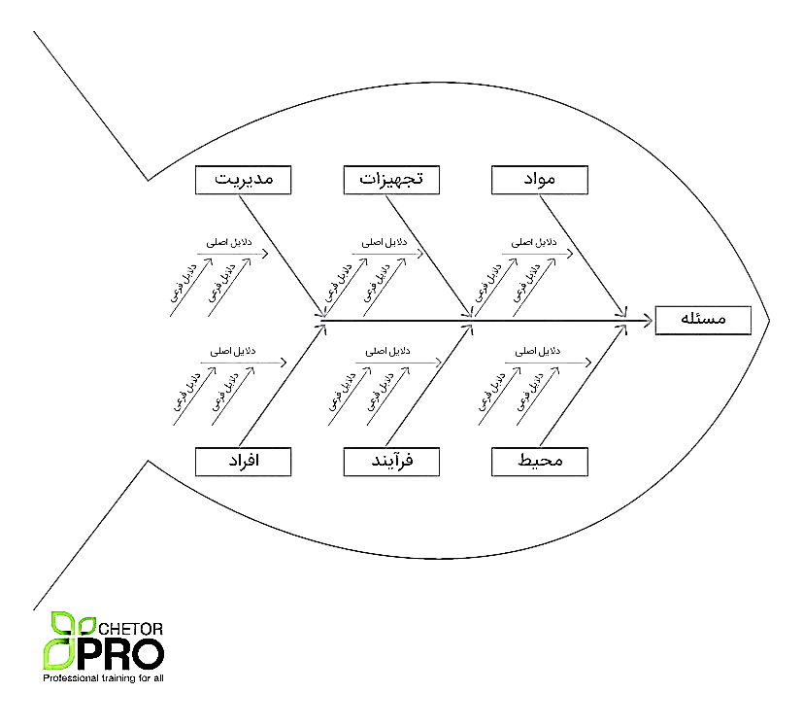

- Do: Implementation of planning processes
- Check: monitoring and measuring activities, and processes, taking into account the goals and policies of the occupational health and safety management system and reporting the results.
- Act: To continuously improve the performance of the occupational health and safety management system to achieve the desired goals

13-1- Operation control from the safety point of view
13-1-1- Guidelines for dealing with specific project safety risks
Incorrect performance of critical HSE tasks has the potential to create negative HSE results. Therefore, regarding these tasks, the instructions are documented and provided to the relevant employees, depending on the project and the risks associated with it, these instructions include the following, but are not limited to:
- Guidelines for safety, public health, and factory requirements
- Safety guidelines, public health, and administrative department requirements
- Safety instructions and work with grinding stones
Toase-ehe Park Sanati Gohar Ofogh
Petrochemical Co.
CONCEPTUAL, BASIC and DETAIL DESIGN ENGINEERING OF STYRENE PARK OFFSITE
 |  | Document Title: HSE PLAN
 |  | Document No.: EI027-FPA-VD-GE-HSE-005 | Rev. R0 | Page 22 of 43

- Safety of working at height
- Safety in Electricity
- Welding and cutting safety
- Work safety in closed spaces
- Safety in sandblast operations
- Storage Safety
- Scaffolding safety
- Safety of working with lifting and carrying equipment
- Safety of working with radioactive materials and X-rays
- Safety in painting
- Guidelines for waste management and waste collection
- Safety of equipment and machinery
- Exposure to harmful factors in the work environment
- Safety instructions for gas cylinders under pressure
- Safety instructions for de-stressing operations
- Forklift safety instructions
- Safety instructions for overhead and gantry cranes
* Example of instructions for safe areas in testing high-pressure tanks
If the test pressure is less than 100 bar and the test temperature is more than 48 degrees Celsius, the proximity in (a 2meter area) should be avoided, and for the test pressure of more than 100 bar and less than or equal to 350 bar and the test, the temperature is more than 48 degrees Celsius, the pressure test should be done on the remote control. A part of the workshop or its vicinity (5meter area) should be blocked and marked with plastic strips by information plates as a danger zone and a prohibited zone
13-2- Operation control from a health point of view
13-2-1- Issues related to public health in the workshop
Maintaining health and getting rid of suffering and illness is one of the most important issues that should always be considered in the workplace as people's second home. To achieve this goal, it is necessary that the work environment is always clean and healthy and avoids things that endanger health.
Sanitary facilities of the workshop:
In Farnikan Pars Avin company, it includes workshop buildings and facilities that are related to ensuring the health conditions of the work environment, such as:
The workshop building is the system of lighting, ventilation, water, sewage, garbage, and all the ancillary facilities of the workshop that are available in the workshop to maintain the health of the workers and their dependents. Such as the dining area, bathroom, dressing room, washroom,

Toase-ehe Park Sanati Gohar Ofogh
Petrochemical Co.
CONCEPTUAL, BASIC and DETAIL DESIGN ENGINEERING OF STYRENE PARK OFFSITE
 |  | Document Title: HSE PLAN
 |  | Document No.: EI027-FPA-VD-GE-HSE-005 | Rev. R0 | Page 23 of 43

drinking room, toilet, prayer room and facilities related to providing first aid are available and facilities related to the coming and going of workers.

13-3- Operation control from an environmental point of view
13-3-1- Waste management
Waste or waste refers to solid, liquid, and gas materials (other than sewage) that are directly or indirectly the result of human activity and are considered waste from the producer's point of view.
The health harms resulting from the lack of waste control have taken an important part in the diseases. If these materials are stored, collected, recycled, or disposed of outside of hygienic principles, a suitable environment is created for the production, growth, and development of insects, rodents, and other harmful organisms, which cause environmental pollution and the spread of various diseases for various reasons. They turn in addition to the possibility of diseases, the lack of control of waste causes pollution of water, soil, air, and the environment of the region.
The HSE unit of Farnikan Pars Avin company with the help of the supervisor of the salon and the personnel collects information related to the type and amount of waste and production waste per month in all departments according to the executive method of identifying, evaluating and controlling the risks and risks of environmental aspects to the code FPA-EPHSE01 It is identified and completed in the waste registration form (FPA-FHSE49) and delivered to the warehouse.
Garbage and waste are collected separately in separate bins and boxes.
Then, the solid waste is transferred to the waste basket after collection by the service force and is collected by the relevant officials of the special collection area and transferred to the appropriate disposal place under the supervision of the environmental organization.
Sanitary waste, such as bandages and contaminated blood gas, is collected in a separate bucket specially designed for this purpose, and isolated in the same way, it is given to the relevant officials for disposal in a suitable place under the supervision of the environmental organization.
After finishing the work, metal scraps are collected in separate boxes and sold by the warehouse and in coordination with the factory management.
Wood scraps are collected in a designated place and used if they are usable. Otherwise, they are sold.
4-13- Workshop equipment
Farnikan Pars Avin company's equipment can include the following:

1- Support building
• Drinking water, water cooler,
• Consumable spare parts warehouse, electrode warehouse, paint and chemicals warehouse, primary material warehouse, scrap warehouse
Toase-ehe Park Sanati Gohar Ofogh
Petrochemical Co.
CONCEPTUAL, BASIC and DETAIL DESIGN ENGINEERING OF STYRENE PARK OFFSITE
 |  | Document Title: HSE PLAN
 |  | Document No.: EI027-FPA-VD-GE-HSE-005 | Rev. R0 | Page 24 of 43

Providing safety and personal protection equipment including (helmet, work clothes, safety shoes, assembly gloves, welding leather gloves, welding leather apron, grinding shield, welding shield, turning safety glasses, safety earpiece, filter breathing mask, and Disposable and chemical, anti-acid work clothes, sandblasting work clothes and...
• Forklift and furnace fuel tanks
• Electricity and water supply systems
• Bathrooms and toilets for the troops
• Sewage collection system
• Garbage collection system
2- Public building
• Fixed and mobile administrative offices (canopy)
• Worker's resort and guest house
• Warehouses
• Staff dining hall
HSE measures to collect wet, dry, and industrial wastes and...
Garbage and waste from each department are collected separately in separate bins for disposal and recyclable.
Then the solid waste after collection is transferred to the waste basket by the service force and collected by the relevant officials of the special area and transferred to the appropriate disposal place under the supervision of the environmental organization.
Sanitary waste, such as bandages and contaminated blood gas, is collected in a separate bucket specially designed for this purpose, and isolated in the same way, it is given to the relevant officials for disposal in a suitable place under the supervision of the environmental organization.
After finishing the work, metal scraps are collected in separate boxes and sold by the warehouse and in coordination with the factory management.
Wood waste is collected in a specific place and used if it can be used. Otherwise, they will be sold.
For other recyclable waste (paper, plastic, and glass), we do the following:
• Ordering special collection bins for restrooms and restrooms and other places by the HSE unit
• Distribution of small buckets in the appropriate number in different units by the service unit.

Toase-ehe Park Sanati Gohar Ofogh
Petrochemical Co.
CONCEPTUAL, BASIC and DETAIL DESIGN ENGINEERING OF STYRENE PARK OFFSITE
 |  | Document Title: HSE PLAN
 |  | Document No.: EI027-FPA-VD-GE-HSE-005 | Rev. R0 | Page 25 of 43

• Cultivation and awareness of all personnel about the importance of recycling by distributing brochures by the HSE unit
• Daily emptying of small bins by the service unit in plastic bags separate from general waste.
• Transfer of the collected materials by the type of materials to the net waste basket by the service unit.
• Sale of salable waste by the warehouse unit in coordination with the management

13-4-1-Safety signs, news signs, obstacles, and warnings
Safety signs are a level of the standard consisting of words, phrases, and images to warn and announce danger. The signs are permanently and sometimes temporarily installed in different parts of the workshop and during work processes.
Classification of safety signs: Safety signs are divided into the following groups based on the type of message and the use of colors:
- Danger and warning signs
- Inhibitory symptoms
- Information signs and safety instructions
- Mandatory and mandatory signs
- Signs related to firefighting
At Farnikan Pars Avin company, safety sign instructions have been developed in the workshop.
It should always be noted that safety signs and symptoms do not protect people from dangers and are only used as a warning and reminder, and appropriate control measures should be considered along with them.
Examples of safety signs used for example include the following:
Warning signs/danger signs/mandatory signs and...

Toase-ehe Park Sanati Gohar Ofogh
Petrochemical Co.
CONCEPTUAL, BASIC and DETAIL DESIGN ENGINEERING OF STYRENE PARK OFFSITE
 |  | Document Title: HSE PLAN
 |  | Document No.: EI027-FPA-VD-GE-HSE-005 | Rev. R0 | Page 26 of 43

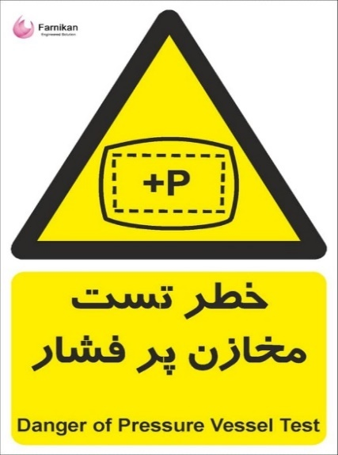 | 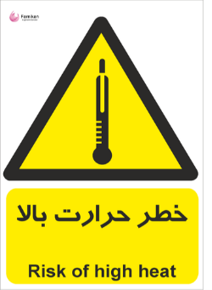
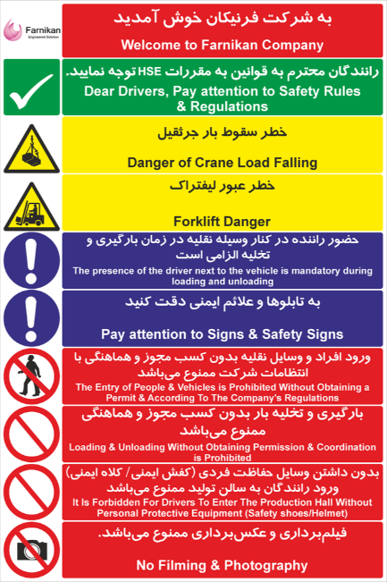 | 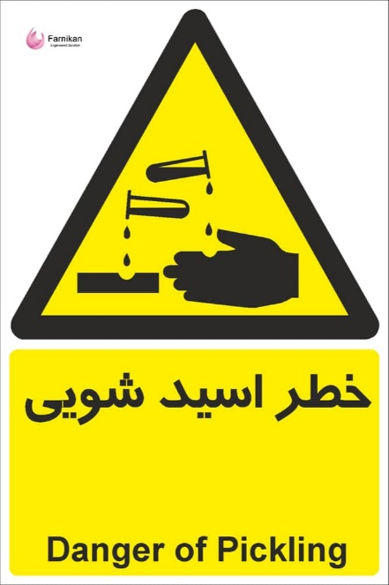

13-4-2-Personal protective equipment

The use of personal protective equipment as the last factor that reduces the severity of the effects of the accident (following the consideration of various protective measures) is of particular importance. This control measure has not eliminated the risk in any way and in many cases, it reduces the consequences of exposure to the risk. Which is done according to the executive method of assigning personal protective equipment with the code (FPA-EPHSE02).

Toase-ehe Park Sanati Gohar Ofogh
Petrochemical Co.
CONCEPTUAL, BASIC and DETAIL DESIGN ENGINEERING OF STYRENE PARK OFFSITE
 |  | Document Title: HSE PLAN
 |  | Document No.: EI027-FPA-VD-GE-HSE-005 | Rev. R0 | Page 27 of 43

13-5- Packing and loading
Loading is done according to the conditions of the workshop and the truck, by a forklift or a crane in such a way that the parts are not damaged during loading and on the way, and the maximum portable volume is loaded.
Duties of employees in loading and unloading goods:
Human resources play a significant role in loading and unloading goods.
Some of the duties of employees in loading and unloading goods are:
- Information about the type of cargo and how to load it
- Monitoring and checking when delivering goods, loading and unloading goods
- Observance of safety points and providing the necessary facilities for equipping the load
- Making the necessary arrangements with the carrier and informing them about the special conditions of the cargo
- Paying attention to the customer's needs when loading, transporting, and unloading goods
- Wearing appropriate clothes, including a safety helmet, during loading
- Ensuring that the loading accessories are safe during loading
Equipment such as belts and rigging accessories are used to move the load with the help of cranes and hoists.
13-6-Using and transporting chemicals
In Farnikan Pars Avin company, the responsibilities for chemicals have been determined, and the types of hazardous chemicals that can be used in the company have been categorized by creating a list of them, as well as labeling them, and they are kept up to date. The safety information sheet of the chemical substance MSDS specifies the general conditions of storage of the substance, the entry and exit rules of these substances, the specifications of the transportation equipment of these substances, the precautions and control measures needed during use (earthing system, ventilation) are placed in the MSDS form of the substance.
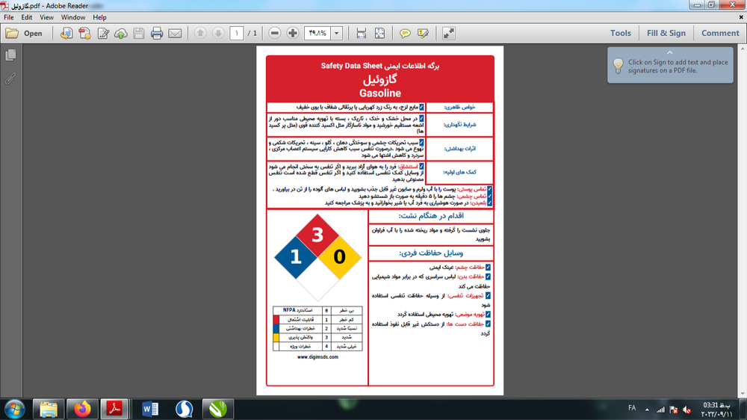

Toase-ehe Park Sanati Gohar Ofogh
Petrochemical Co.
CONCEPTUAL, BASIC and DETAIL DESIGN ENGINEERING OF STYRENE PARK OFFSITE
 |  | Document Title: HSE PLAN
 |  | Document No.: EI027-FPA-VD-GE-HSE-005 | Rev. R0 | Page 28 of 43

14-Executive methods compiled in HSE unit
Examples of HSE inspection cases can include the following, although it is not limited to these cases:
Inspection of communication systems, chemical materials, compressed air systems, electrical systems, environment, and related aspects, fire alarm and extinguishing equipment, emergency evacuation and exit routes and ways, workshop organization, cargo handling equipment, machines, accesses and exits, personal protection equipment, equipment and tools, work execution surfaces, work hygiene, warehouse...
A- Executive method of managing the identification, assessment, and control of risks and risks of environmental aspects FPA-EPHSE01
Identifying the risks and aspects related to the project is done in 3 main stages of the project, i.e., unloading, project implementation, and packing and loading of the project.
The risks associated with the identified risks and related aspects will be evaluated by a team consisting of HSE unit personnel and experienced personnel of each unit by the relevant implementation method. By determining their priority to determine the risk control measures, to reduce the probability or reduce the effects or eliminate the risks, he informs the CEO in the form of corrective, preventive measures and suggestions with the code (FPA-FQA06).
The major and predictable risks associated with work activities in the project are extracted by brainstorming techniques and the use of inspection checklists and visits to places and locations, as well as observing the records of past incidents and interviewing experienced employees, but the major risks and Inherent in this project are the risks associated with the following activities:
  - Work at a height
  - Working with electrical equipment and devices
  - Welding and cutting operations
  - Acid washing operation of metals
  - Working in the enclosed space of tanks under construction
  - Sandblasting and industrial paint operations
  - inventory
  - Scaffolding
  - Working with lifting and carrying equipment
  - Working with radioactive materials and X-rays
  - Thermal stress relief furnace operation
  - Testing high-pressure tanks
  - Use of equipment and machinery
  - Exposure to harmful physical factors in the work environment such as noise caused by equipment and machinery, light, etc.
  - Exposure to dust, fumes, and vapors from different materials
Toase-ehe Park Sanati Gohar Ofogh
Petrochemical Co.
CONCEPTUAL, BASIC and DETAIL DESIGN ENGINEERING OF STYRENE PARK OFFSITE
 |  | Document Title: HSE PLAN
 |  | Document No.: EI027-FPA-VD-GE-HSE-005 | Rev. R0 | Page 29 of 43

  - Moving equipment with a crane
  - Forklift safety
  - Storage and handling of materials and equipment
  - And...

In all identified risks, the following will be considered:
  - Personnel and stakeholders related to the activity
  - Equipment used in the activity
  - The impact of people and equipment on the environment (water, soil, air)
During the duration of the project, all personnel will always be encouraged to recognize correct, and update risks as a duty whenever possible.
In Farnikan Pars Avin Company, identification, and evaluation of risks in the field of HSE (equipment, activities, safety, health, and environment) is done by the FMEA method.
FMEA in risk assessment is an analytical method that tries to identify and rank as many potential threats as possible in the range in which the risk assessment is carried out, as well as the causes and effects of it. Risk control is based on the decision criteria table and based on the principle of ALARP (As Low As Reasonably Practicable).
The major and predictable environmental aspects related to work activities in the project include the following:

  - Polluting aspects include:
- Soil pollution caused by spillage of oil, petroleum substances, and other soil pollutants
- Air pollution caused by smoke from project machinery, metal fumes, etc.
- Water pollution caused by sanitary sewage in the workshop
- Noise pollution caused by workshop activities
  - Consumption aspects include:
- High consumption of fuel (gasoline)
- Excessive water consumption
To correctly identify the positive and negative aspects in the form of environmental opportunities and threats, it is necessary to identify different and potential resources in the processes. These resources include the following:
  - Obvious sources that produce pollution and prevent pollution, such as waste production, sewage, etc.
  - Inconspicuous sources of pollution such as gas leaks from connections and...
  - All environmental aspects in distribution networks and branches
  - Other activities of the company such as repair and maintenance, storage, general activities, etc.

Toase-ehe Park Sanati Gohar Ofogh
Petrochemical Co.
CONCEPTUAL, BASIC and DETAIL DESIGN ENGINEERING OF STYRENE PARK OFFSITE
 |  | Document Title: HSE PLAN
 |  | Document No.: EI027-FPA-VD-GE-HSE-005 | Rev. R0 | Page 30 of 43

B- Executive method of preparation in emergencies
To prevent the consequences caused by the occurrence of events, the executive method of preparation and response in emergencies with the code (FPA-EPHSE04) is used.
Emergency conditions: These include unusual events that threaten the safety, health, or general comfort of the organization's people, or largely endanger the environment. This issue can cause the general deviation of the organization from the policy.
Crisis: If emergencies are not properly controlled, they may spread outside the industrial environment and affect society as well. In this case, the emergency becomes a crisis or a disaster and requires more comprehensive planning, and can adversely affect the reputation of the organization, its future, and its production process.
To prevent the consequences of events, an Emergency Plan has been considered in the HSE Plan. The items considered in the formulation of the Emergency Plan include the following:
• The management representative is responsible for monitoring and reporting on emergency response and maneuvers.
• The responsibility of identifying emergencies, conducting maneuvers, and documenting the results is the responsibility of the occupational health and safety expert.
At the beginning of the matter, according to the conditions, activities, and work processes, each of the levels 1, 2, and 3 incidents have been defined before the occurrence of the incident and the necessary measures in case of occurrence of each of the incidents have been specified in advance.
Level 1 incident:
It is an incident that has the potential to become a crisis, but if we use the golden time, the company itself can control it.
Level 2 incident:
It is an accident that, if it happens, also involves nearby organizations or companies. And we should get help from other organizations.
Level 3 incident:
It is an accident that affects the region if it happens, and regional aid should be used as well.
The responsibility of people for each level 1, 2, and 3 incidents has been determined according to the form of responsibilities in emergencies (Responsibility Matrix).
The Emergency Contact List is available to make contact in emergencies with the responsible people of the company, the workshop, as well as all relief institutions and organizations.
How to declare an emergency and evacuate personnel:
Each of the personnel is obliged to announce the matter as soon as they see an incident such as a fire, explosion, chemical spill, etc.

Toase-ehe Park Sanati Gohar Ofogh
Petrochemical Co.
CONCEPTUAL, BASIC and DETAIL DESIGN ENGINEERING OF STYRENE PARK OFFSITE
 |  | Document Title: HSE PLAN
 |  | Document No.: EI027-FPA-VD-GE-HSE-005 | Rev. R0 | Page 31 of 43

As soon as the news is received or announced by the siren or loudspeakers, all the personnel of the relevant unit with the cooperation of the person in charge of that unit or workshop leave the place of the accident through the exits and to protect themselves and prevent interference in the fire fighting, rescue and rescue operations. And... census takers gather at the muster point.
Safe gathering place:
A predetermined place where all employees gather in the event of a fire, release of hazardous materials, or any other event that requires the evacuation of buildings. In this place, all personnel are guided for the next steps.
Responsibilities:
Normally, the responsibilities of a crisis committee are as follows, which of course can be expanded or reduced according to the conditions and levels of the incident.
Crisis Committee: A committee that organizes and integrates rapid response teams based on the response plan in emergencies to deal with crises and emergencies. The most important task of this committee is to minimize the loss of life and property in emergencies. This committee consists of the person in charge of occupational health and safety, the supervisor of all salons, and a team of 5 workers from each salon who have completed training courses in firefighting, rescue, and emergency preparedness.
Preparation of report:
After the accidents, the HSE unit convenes a meeting with the cooperation of the officials of the units and the unit affected by the accident, and while reviewing and preparing the report, the proposals presented are reviewed and analyzed, and the approvals of this meeting are followed up by the HSE supervisor. The output of the meetings can be corrective and preventive measures needed, such as predicting the necessary training, and required equipment, modifying instructions, and conducting more periodical exercises.
Periodic exercises (maneuvers):
To prepare as much as possible for emergencies, periodical exercises are carried out every six months in coordination with the HSE unit. To carry out the maneuver of each of the level 2, 1, and 3 incidents, scenarios should be written in advance and all the activities and actions used should be scheduled and the responsibilities should be specified. After each exercise, the maneuver evaluation form is completed by the HSE supervisor. If there are weaknesses in the performance, suggestions for improvement should be given.

Cleaning the environment:
After controlling the incident, the relevant environment must be completely cleaned. How to act in each of the emergencies is described in the relevant instructions.

Toase-ehe Park Sanati Gohar Ofogh
Petrochemical Co.
CONCEPTUAL, BASIC and DETAIL DESIGN ENGINEERING OF STYRENE PARK OFFSITE
 |  | Document Title: HSE PLAN
 |  | Document No.: EI027-FPA-VD-GE-HSE-005 | Rev. R0 | Page 32 of 43

Preparation of report:
The accident report is prepared by the HSE supervisor of the workshop and presented to the management representative and HSE representative of the employer.
After the occurrence of accidents, the safety and protection committee convene a meeting and prepares a report while examining the suggestions and analyzing them, and the approvals of this meeting are followed up by the safety and protection committee. The output of the meetings can be corrective and preventive measures needed, such as predicting the necessary training, and required equipment, correcting the instructions, and conducting more periodical exercises.
Education:
All personnel involved in controlling and controlling emergencies have received the necessary training and are sufficiently prepared to deal with emergencies.
Health measures in emergencies:
Special health measures are necessary to identify and deal with problems (such as the spread of infectious diseases) in emergencies. These measures, in addition to the usual health measures, are managed by the HSE unit, such as public information in the shortest time, checking of suspicious people, monitoring and inspection of different parts based on the regulatory plan for the management of special conditions by the HSE unit and the company's health department. Doing some other things that are done under the direction of the management.
C - Implementation method of allocating personal protective equipment:
The HSE unit first prepares a list of the jobs available in the company and records the duties of the workers in each of the jobs, including routine duties and non-routine duties, in the relevant form and implements the risk assessment program to identify risky activities for the workers. and records the identified risks, then records a list of personal protective equipment needed by each job to reduce contact and complete worker protection against the mentioned risks and the useful life of the equipment in the relevant form and as the reference for the provision of the equipment is used. The HSE unit, by the standard safety equipment determined by the Ministry of Health, Ministry of Labor and Social Affairs and based on the information collected in the previous stages, purchased the appropriate number, model, and type of each of the required equipment, and the warehouse manager is obliged to provide protective equipment. The person who receives the worn-out equipment from the people and provides them with the new equipment according to the size and standard records the relevant documents, and then takes the commitment to use and maintain the personal protective equipment, signature, and fingerprints from the receiving person and files it.
The HSE unit teaches personnel how to use and maintain personal protective equipment during designated training courses according to the company's training program. During periodical monitoring of the workshop, he obliges the employees to use these devices in their jobs and ensures the proper use of personal protective equipment by the workers.

Toase-ehe Park Sanati Gohar Ofogh
Petrochemical Co.
CONCEPTUAL, BASIC and DETAIL DESIGN ENGINEERING OF STYRENE PARK OFFSITE
 |  | Document Title: HSE PLAN
 |  | Document No.: EI027-FPA-VD-GE-HSE-005 | Rev. R0 | Page 33 of 43

D- Implementation method of corrective and preventive measures:
For the continuous and effective improvement of the health, safety, and environmental situation, it is necessary to define appropriate corrective and preventive measures to resolve potential and actual non-compliance cases that may appear in the system. The company has defined the responsibility and authority to initiate a corrective action investigation regarding incidents that do not conform to specific requirements related to the HSE management system and its operations or results. and follows the implementation procedure of corrective and preventive actions with the code (FPA-EMQA02).

E- Implementation method of incident reporting and investigation:
This company will try to record events to manage accidents and also to prevent the occurrence of predictable accidents and the recurrence of accidents. In this sense, the implementation method of reporting and investigating incidents with the code FPA-EMHSE03 is used.
All incidents and events at different levels are recorded in the incident and events registration table in Excel format.
In case of an accident in different units of the company, the HSE unit has taken the following necessary measures

  - Ensuring the safety of the event/incident scene
  - Transfer the injured to the emergency room
  - Assessing the risk of investigative operations at the event/incident scene.
  - Determining the status of the system and equipment at the scene of the incident.
  - Identifying and evaluating the possibility of restarting the incident during the investigation.
  - Identifying changes in the production process, systems, personnel, repairs, design, suppliers,
  - , etc
and cooperates with the company's security in the following cases:
Enclosing the accident site and collecting information, the consequences of the accident in terms of manpower, stopping production, damage to the environment, and damage to facilities and equipment, collecting evidence and objective data of the accident based on the consequences of the accident, including the list of personnel involved in the accident, the list Damaged equipment, hours of production stoppage, list of rescue and rescue control measures and restoration to pre-accident conditions, filming and photographing of the accident site and report of incident management measures and dealing with emergencies, initial interview with the people involved in the accident.
The accident site must be quarantined and the damaged materials and equipment must be taped and separated from the other parts.

Toase-ehe Park Sanati Gohar Ofogh
Petrochemical Co.
CONCEPTUAL, BASIC and DETAIL DESIGN ENGINEERING OF STYRENE PARK OFFSITE
 |  | Document Title: HSE PLAN
 |  | Document No.: EI027-FPA-VD-GE-HSE-005 | Rev. R0 | Page 34 of 43

Analyzing the evidence and data of the incident is the most important step in investigating the incident/incident to identify the causal factors of the incident/incident. Through a causal factor, several root causes of the accident will be known.
The supervisor of the salon informs the HSE department about the incident through the accident report form. The occupational health and safety unit completes the accident report form by referring to the place, investigating the accident, and following up with the injured, the supervisor, and the witnesses of the accident, and if necessary, issues a corrective or preventive action form. If the severity of the accident is high and there is a need to rest for more than 3 days, the Social Security accident report form is completed and delivered to the company's administrative unit to be sent to the insurance department, as well as the accident report to the liability insurance company, the statistics of patients and accident victims. It is sent to the labor office at the end of every month.
Then, in 6-month periods, the analytical report of the root causes of events, which includes the frequency/severity of the incident/age/work experience/months of occurrence/days of occurrence/hours of occurrence/cause of the accident/causes of unsafe acts/source of injury / injured member/location / Involved units provide a review and report to the management representative and it is recorded in an excel file and sent to the labor department and the health center. Based on this, if needed, corrective/preventive measures will be implemented with code FPA-EMQA02.

Toase-ehe Park Sanati Gohar Ofogh
Petrochemical Co.
CONCEPTUAL, BASIC and DETAIL DESIGN ENGINEERING OF STYRENE PARK OFFSITE
 |  | Document Title: HSE PLAN
 |  | Document No.: EI027-FPA-VD-GE-HSE-005 | Rev. R0 | Page 35 of 43

- After any accident/ quasi-accident/ damage to property and equipment, it is immediately reported to the HSE unit and the supervisor of the unit.
- The accident report will be prepared by the head of the relevant unit within 24 hours and will be provided to the relevant authorities (social security department) and civil liability insurance.

Supervisor of the unit/workshop
- Carrying out the necessary follow-ups in order to ensure the full containment of the incident
- Prepare a report of the event (if necessary, interview witnesses and prepare photos and videos) within 48 hours with the cooperation of the HSE unit and other personnel.
- Information to other responsible people in the project
HSE unit of the company
- Incident control with the help of trained people and security
- Sending possible injured persons for treatment to medical centers/requesting help from rescue centers
- Cooperating with the supervisor of the unit/workshop in preparing the incident report

Company Safety Committee
- Detailed investigation of the accident and approval of the necessary measures to prevent the recurrence of the accident
- Informing other units about the manner and causes of the incident
- Notification of the accident to the liability insurance within 3 working days

14-2- HSE inspection
To ensure the proper functioning of the HSE system at the project level and also to recognize the commitment of project people to HSE issues, it is necessary to conduct safety, health, and environmental inspections. For this purpose, a section under the title of HSE inspection has been considered in the safety, health, and environment plan.

Toase-ehe Park Sanati Gohar Ofogh
Petrochemical Co.
CONCEPTUAL, BASIC and DETAIL DESIGN ENGINEERING OF STYRENE PARK OFFSITE
 |  | Document Title: HSE PLAN
 |  | Document No.: EI027-FPA-VD-GE-HSE-005 | Rev. R0 | Page 36 of 43

14-2-1- Planned inspections:
To fulfill the purpose of this executive method, the HSE unit conducts periodic inspections of all units, production lines, and workplaces according to the safety inspection schedule based on safety, occupational health, and environmental inspection checklists. After these checklists are completed, the defects are fixed according to the implementation method of corrective and preventive action with the code (FPA-EPQA02).
14-2-2- Case and daily inspections:
In addition to scheduled inspections, the HSE unit conducts daily or occasional inspections of the work environment. Also, according to the telephone or written reports of the employees and units, he visits the referred cases.

HSE inspection includes but is not limited to the inspection of the following items:

The frequency of inspection | By | Activity/ equipment to be inspected
Daily before use | Qualified operator / HSE | Cargo handling equipment
Daily before use/weekly period | Qualified operator / technical maintenance and repair unit | Electric wire and electric cables of devices and machines
Daily before use | Qualified Operator/HSE | Welding and cutting equipment
Daily before use | Qualified Operator / HSE | Hand tools
Daily before use | Qualified operator / HSE | Forklift inspection
Monthly periodical | Qualified operator/HSE | Inspection of cranes
Daily before use | Qualified operator / HSE | Inspection of elevators

Note: To facilitate and standardize the inspections, checklists have been considered for this category.

14-3- Modification and suspension of operation
If during the implementation of the project, unsafe operations and conditions are observed in such a way as to create risks or aspects that have unacceptable consequences for the company, it is necessary to take appropriate action quickly to correct the situation, for this purpose, it is necessary to stop the dangerous operation first. and after resolving the discrepancy on a case-by-case basis, to prevent the repetition of similar cases, if necessary, corrective measures should be taken by the procedure defined above.

Toase-ehe Park Sanati Gohar Ofogh
Petrochemical Co.
CONCEPTUAL, BASIC and DETAIL DESIGN ENGINEERING OF STYRENE PARK OFFSITE
 |  | Document Title: HSE PLAN
 |  | Document No.: EI027-FPA-VD-GE-HSE-005 | Rev. R0 | Page 37 of 43

15- Review
The company's management reviews the HSE management system and its performance at appropriate time intervals, to ensure its continuity, appropriateness, and effectiveness, and in the review, the following items are addressed, but not limited to these items:
  - The need for possible changes in policy and goals in the light of changing conditions and the commitment to strive for continuous improvement.
  - Allocation of resources for the establishment and maintenance of the HSE management system
  - Location and/or situations based on assessed hazards and risks and emergency planning

16-Commitment to the implementation of the HSE plan

Toase-ehe Park Sanati Gohar Ofogh
Petrochemical Co.
CONCEPTUAL, BASIC and DETAIL DESIGN ENGINEERING OF STYRENE PARK OFFSITE
 |  | Document Title: HSE PLAN
 |  | Document No.: EI027-FPA-VD-GE-HSE-005 | Rev. R0 | Page 38 of 43
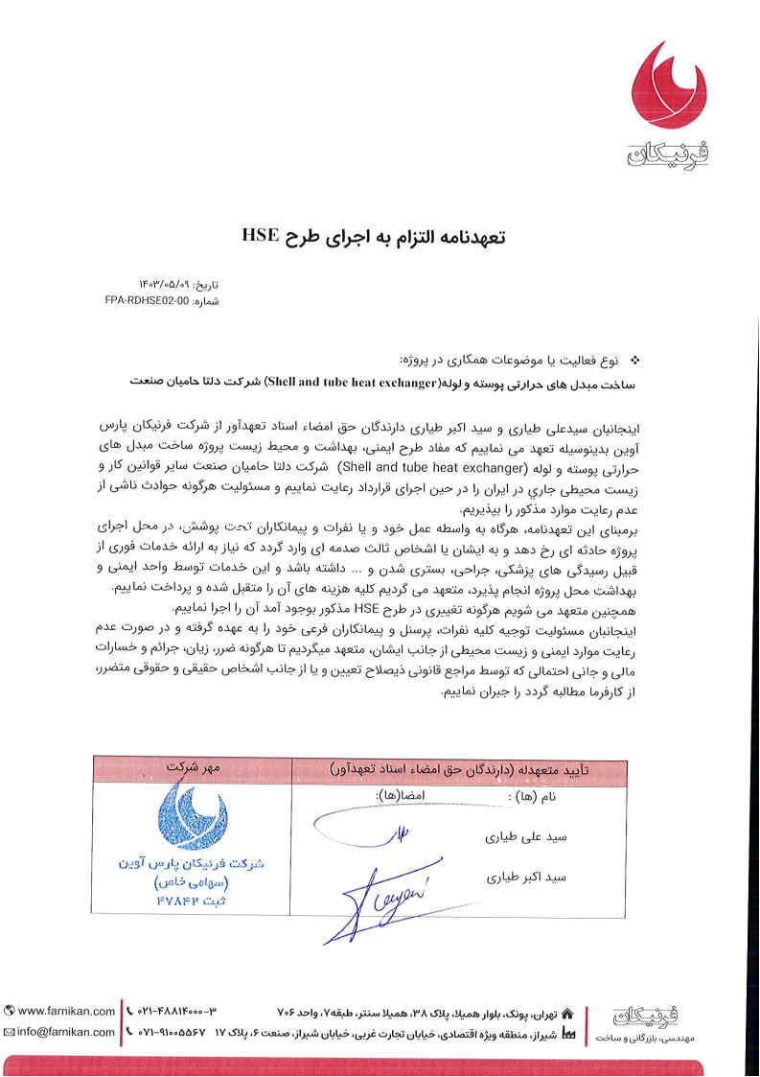

Toase-ehe Park Sanati Gohar Ofogh
Petrochemical Co.
CONCEPTUAL, BASIC and DETAIL DESIGN ENGINEERING OF STYRENE PARK OFFSITE
 |  | Document Title: HSE PLAN
 |  | Document No.: EI027-FPA-VD-GE-HSE-005 | Rev. R0 | Page 39 of 43
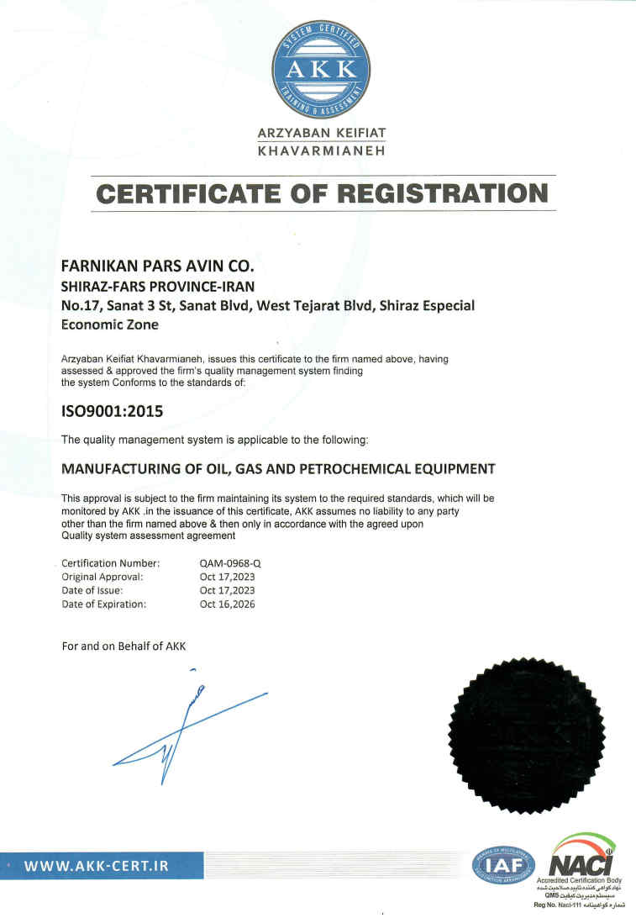

Toase-ehe Park Sanati Gohar Ofogh
Petrochemical Co.
CONCEPTUAL, BASIC and DETAIL DESIGN ENGINEERING OF STYRENE PARK OFFSITE
 |  | Document Title: HSE PLAN
 |  | Document No.: EI027-FPA-VD-GE-HSE-005 | Rev. R0 | Page 40 of 43
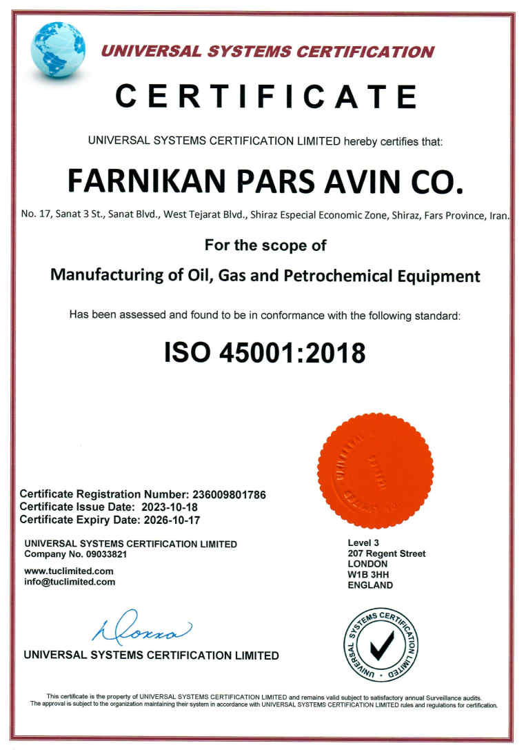

Toase-ehe Park Sanati Gohar Ofogh
Petrochemical Co.
CONCEPTUAL, BASIC and DETAIL DESIGN ENGINEERING OF STYRENE PARK OFFSITE
 |  | Document Title: HSE PLAN
 |  | Document No.: EI027-FPA-VD-GE-HSE-005 | Rev. R0 | Page 41 of 43
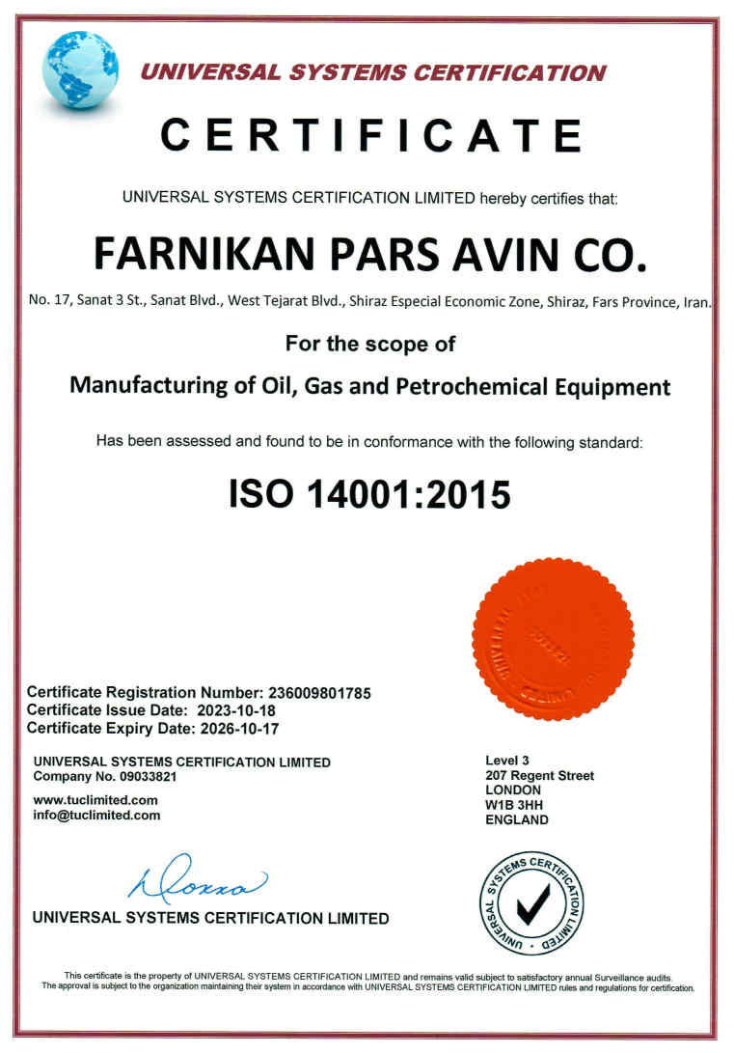

Toase-ehe Park Sanati Gohar Ofogh
Petrochemical Co.
CONCEPTUAL, BASIC and DETAIL DESIGN ENGINEERING OF STYRENE PARK OFFSITE
 |  | Document Title: HSE PLAN
 |  | Document No.: EI027-FPA-VD-GE-HSE-005 | Rev. R0 | Page 42 of 43
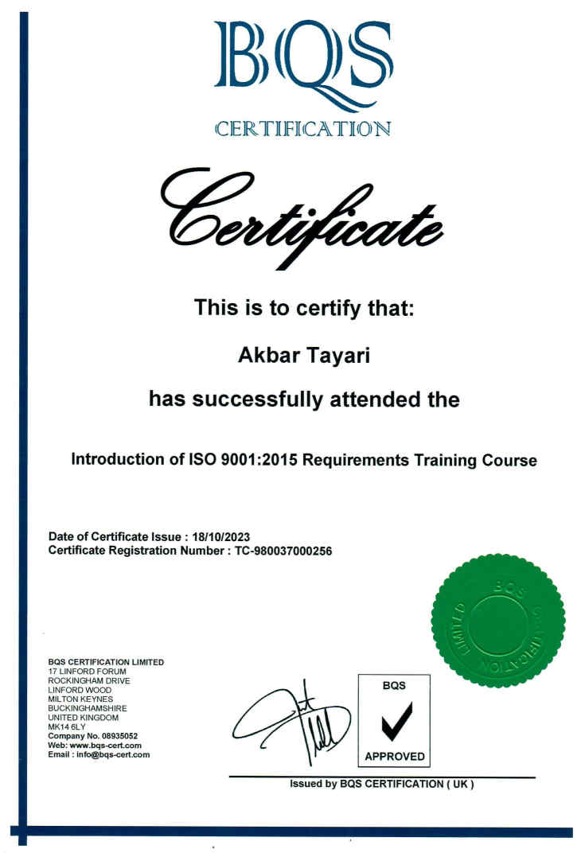

Toase-ehe Park Sanati Gohar Ofogh
Petrochemical Co.
CONCEPTUAL, BAS,IC and DETAIL DESIGN ENGINEERING OF STYRENE PARK OFFSITE
 |  | Document Title: HSE PLAN
 |  | Document No.: EI027-FPA-VD-GE-HSE-005 | Rev. R0 | Page 43 of 43
